Instruction for Presentation

Option 1: Using UNCW facility.
  - Supported file format: PDF or PowerPoint.
  - File must store on a USB drive.
  - Selected “PC” from the control center and insert USB drive to PC USB port.

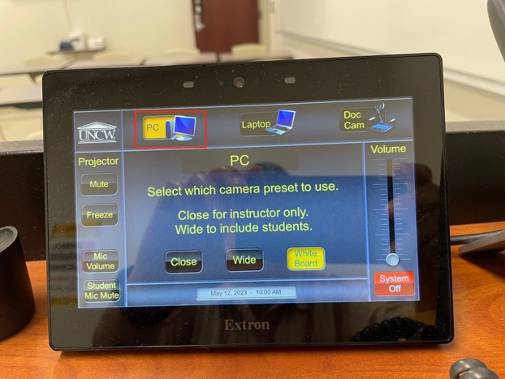

Option 2: Using a personal computer.
  - Must have a HDMI or VGA connector. If you are using a personal computer with a different video port (such as MacBook, etc.), you must bring your own adaptor. The conference will NOT provide any.
  - Select “Laptop” from control center first, then select correct video port.

